3.Write a partial function to add three numbers in which one number is constant and two

numbers can be passed as inputs and define another method which can take the partial

function as input and squares the result.

**Source code :**

**Assignment15.2.scala**

class PartialClass

{

def squareFunc(x :Int) :Unit = {

println("Square = "+ x*x) //define a function to square the input's

}

def addition(x: Int, y: Int, z: Int) = x+y+z //a function to add constant+value1+value2

val add=addition(5, _:Int,_:Int) // the constat values = 5

def partialFunc(a: Int, b: Int) :Unit = { //another method to define a value for constant.

println("Addition = " +add(a,b))

squareFunc(add(a,b))

}

}

**partialFunctionObj.scala**

object partialFunctionObj { // SingleTon object to call the functions

def main (args:Array[String]) :Unit = {

println("Enter the values of the number : ")

var a:Int = readLine().toInt

var b:Int = readLine().toInt

new PartialClass().partialFunc(a,b)

}

}

**Output:**

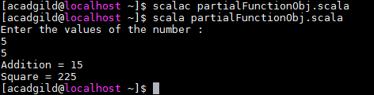

4.Write a program to print the prices of 4 courses of Acadgild: Android-12999,Big Data

Development-17999,Big Data Development-17999,Spark-19999 using match and add a

default condition if the user enters any other course.

**Source code :**

object patternmatch

{

def result (x: String ) :String =x match

{

case "Android" => ("Android course price is 12999/-")

case "Big Data Development" => ("Big Data Development price is 17999/-")

case "Spark" => ("Spark prices is 19999")

case _=> ("This course is not available ")

}

def main(args:Array[String]): Unit =

{

println(result("Big Data Development")

}

}

**OutPut :**

